HDFS Assignment

1. Create a new HDFS file structure data/dev/analysis in the HDFS home directory.

Copy the covid-19 folder in to it.

Hdfs dfs -mkdir-p data/dev/analysis

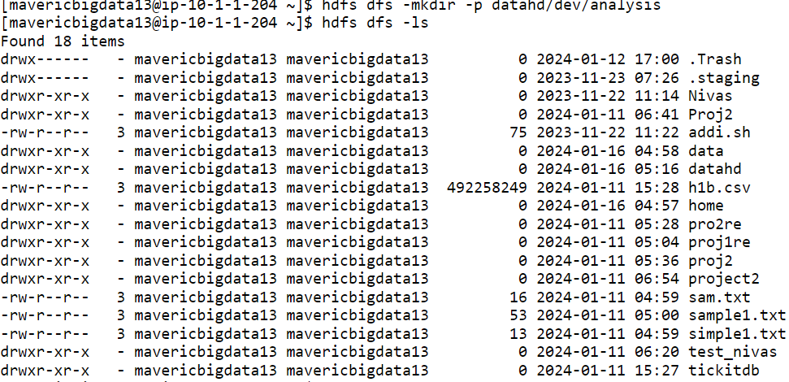

hdfs dfs -ls -R



Hdfs dfs -put covid19   data/dev/analysis

2. Change the permission of Covid_patient_Apr26.csv file to have only

read/write/execute for the owner/ group and read/write permission for others.

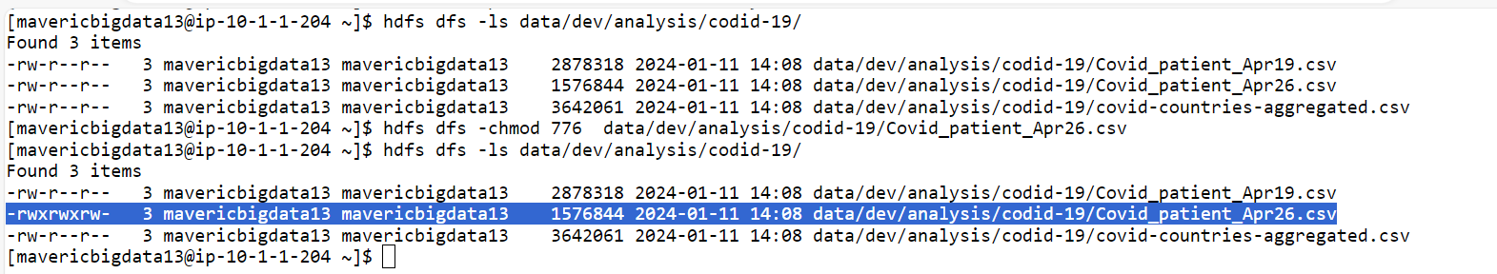

3. Copy covid-19 folder in to another hdfs directory data/prod/analysis

4. Read the contents of the file Covid_patient_Apr19.csv and print the contents on the

Screen\

Hdfs dfs -cat data/dev/analysis/codid-19/ covid_patient_Apr19.csv

5. Print the no of lines present in the HDFS file Covid_patient_Apr19.csv

Hdfs dfs -cat data/dev/analysis/codid-19/Covid_patient_Apr19.csv | wc -l

6. Count the no of records present in the HDFS file Covid_patient_Apr19.csv for the

state “UP”

Hdfs dfs- count covid_patient_Apr19.csv | grep ‘,UP,’

7. Delete the file Covid_patient_Apr19.csv from the data/prod/analysis folder in HDFS

Hdfs dfs -rm  data/prod/analysis/codid-19/Covid_patient_Apr19.csv

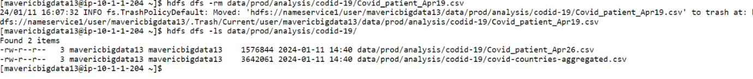

8. Delete the covid-19 folder from both the dev and prod folders created above.

Hdfs dfs -rm -R data

Hdfs dfs -rm -R  data/prod/analysis/codid-19/Covid_patient_Apr19.csv

Hdfs dfs -rm -R  data/dev/analysis/codid-19/Covid_patient_Apr19.csv

9. Copy the tickitdb folder(in the local file system) in to HDFS home directory. How

many blocks will be created for the files in this directory?

Blocks creation check using fsck command

10. Find all the file names which has the word “pipe” in their names.

11. Copy the h1b.csv file to hdfs home directory. How many blocks will be created for

this file?

Hdfs dfs -put h1b.csv

Block creation checking using fsck cmd

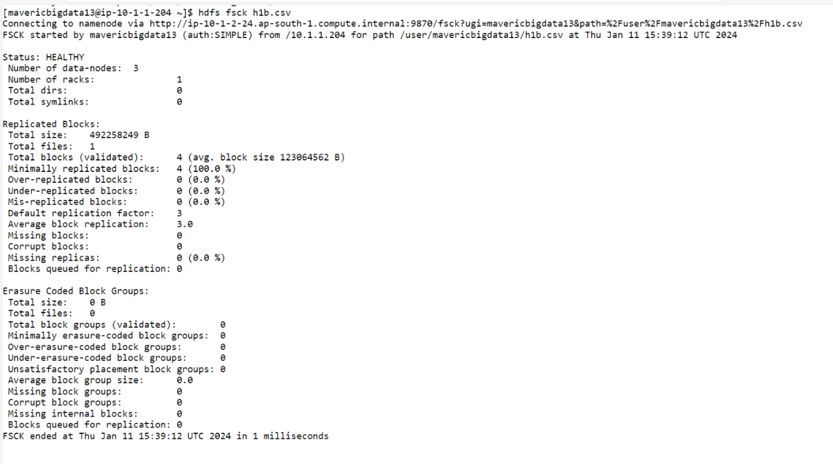

12. Move the h1b.csv file (in the HDFS) to the tickitdb folder in hdfs. How many block will be there for the tickitdb folder?

Block Creation check using fsck cmd

